**SIMATS SCHOOL OF ENGINEERING**

**SAVEETHA INSTITUTE OF MEDICAL AND TECHNICAL SCIENCES**

**CHENNAI-602105**

**Resilient computing architecture for space exploration**

**A CAPSTONE PROJECT REPORT**

*Submitted in the partial fulfillment for the award of the degree of*

**BACHELOR OF ENGINEERING**

**IN**

**COMPUTER SCIENCE ENGINEERING**

**Submitted by**

**K. LAKSHMI (192211986)**

**P. BHUVANESHWARI (192210499)**

**S. SUGUMAR (192121059)**

**Under the Supervision of**

**Dr. IRIN LORETTA**

**Table of Contents**

|  |  |
| --- | --- |
| **S.NO** | **TOPICS** |
| **1** | **Abstract** |
| **2** | **Introduction** |
| **3** | **LITERATURE REVIEW** |
| **4** | **Resilient Computing Solutions**   1. Redundant Systems 2. Fault Tolerance 3. Real-time Monitoring |
| **6** | **Design** |
| **7** | **Analysis** |
| **8** | **conclusion** |

**ABSTRACT**

Space exploration presents unique challenges due to harsh environmental conditions, vast distances, and communication delays. Resilient computing architectures are essential for ensuring the success of space missions by mitigating the impact of these challenges on spacecraft systems. This abstract discusses the importance of resilient computing architectures in space exploration, outlining key objectives such as hardware redundancy, fault-tolerant algorithms, robust communication protocols, and rigorous testing. By integrating these elements, space agencies can enhance the reliability and resilience of their systems, enabling safe and successful exploration of the cosmos. Continued research and innovation in resilient computing architectures are vital for advancing the frontiers of space exploration and supporting future manned and unmanned missions to explore new worlds. Resilient computing refers to the design and implementation of computer systems that can withstand and recover from various types of failures or disruptions. Resilient computing is crucial for space exploration missions, where systems must operate in extreme environments and face the risk of radiation, power outages, and other potential failures.

**OBJECTIVE**

* Design resilient computing architectures capable of withstanding radiation, temperature variations, and hardware failures.
* Develop fault-tolerant algorithms and protocols to ensure continuous operation in the face of unexpected events.
* Implement robust communication protocols to mitigate the effects of latency and packet loss.
* Test and validate the reliance of the proposed architectures through simulations and, where feasible, real-world experiments.
* Create autonomous systems capable of self-diagnosis, self-repair, and adaptive decision-making without human intervention.
* Incorporate hardware redundancy at system, module, and component levels to enhance system reliability.
* Enhance space exploration missions' success and astronaut safety by advancing the reliability and resilience of computing systems deployed in space.

**INTRODUCTION**

Space exploration stands at the forefront of human endeavour, pushing the boundaries of technology and human ingenuity. Yet, the harsh and unforgiving environment of space presents immense challenges to the reliability and functionality of computing systems. In this context, the concept of resilient computing architectures emerges as a critical area of focus. Resilient computing architectures for space exploration are designed to withstand the rigors of space, including radiation, extreme temperatures, and hardware failures, while ensuring the continuous operation of vital systems. These architectures are essential not only for the success of space missions but also for the safety and well-being of astronauts who venture into the vast expanse of the cosmos.

The resilience of computing architectures in space exploration is paramount due to the unique challenges posed by the space environment. Cosmic radiation, solar flares, and micrometeoroids can all pose significant threats to the integrity of electronic components and data stored within computing systems. Moreover, the vast distances involved in space exploration introduce communication delays and potential signal disruptions, necessitating robust communication protocols. Resilient computing architectures address these challenges by incorporating hardware redundancy, fault-tolerant algorithms, and communication protocols optimized for space missions.

As humanity continues to expand its presence in space, resilient computing architectures play a pivotal role in enabling the success of future missions. Whether exploring distant planets, establishing habitats on celestial bodies, or venturing beyond the confines of our solar system, resilient computing architectures provide the foundation for safe and reliable operation in the harsh and unpredictable environment of space. By advancing the field of resilient computing architectures for space exploration, we pave the way for new discoveries, scientific breakthroughs, and the continued exploration of the cosmos for generations to come.

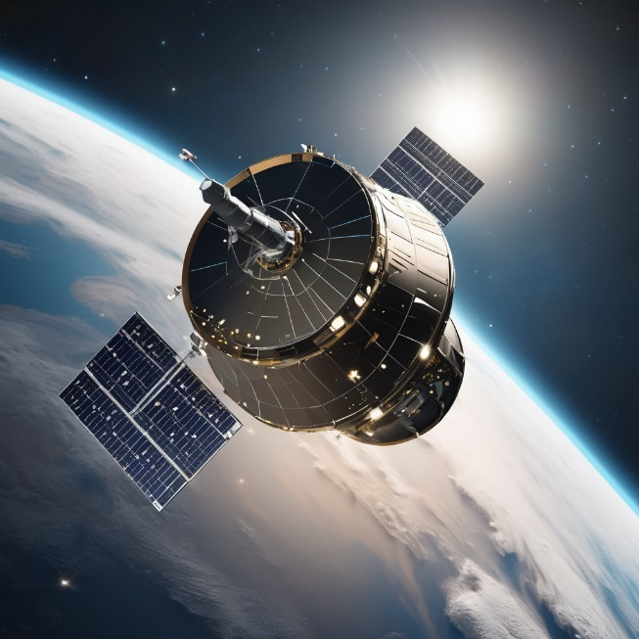 

Space exploration represents one of humanity's greatest endeavours, pushing the boundaries of our understanding and capabilities. However, venturing into the cosmos presents formidable challenges, including harsh environmental conditions, radiation exposure, and vast distances from Earth. Ensuring the reliability and resilience of computing architectures is paramount for the success of space missions, whether manned or unmanned. Resilient computing architectures are designed to withstand the rigors of space, enabling spacecraft and their onboard systems to function effectively despite the hostile environment. This entails developing hardware and software solutions capable of tolerating failures, adapting to dynamic conditions, and maintaining communication in the face of challenges such as latency and packet loss. By harnessing advanced technologies and innovative approaches, resilient computing architectures pave the way for safer, more robust space exploration endeavours.

In this report, we delve into the intricacies of resilient computing architectures tailored specifically for the unique demands of space exploration, exploring their design principles, fault-tolerant algorithms, communication protocols, and validation methodologies. Through concerted efforts in research, development, and testing, resilient computing architectures promise to enhance the reliability and success of future space missions, unlocking new frontiers in our quest to explore the cosmos.

**LITERATURE REVIEW**

The literature review phase of the research project on "Resilient Computing Architectures for Space Exploration" involves a thorough examination of existing scholarly works, research papers, articles, and relevant sources pertaining to resilient computing architectures in the context of space exploration. This phase serves as the groundwork for comprehending the current landscape of knowledge in this domain and for identifying gaps, challenges, and avenues for further exploration. The literature review encompasses several key objectives and activities:

Identification of Relevant Literature: The initial step entails systematically scouring databases, academic journals, conference proceedings, and reputable sources for literature related to resilient computing architectures, space exploration, and related topics. Utilizing appropriate keywords and search terms ensures a comprehensive and focused search.

Review and Analysis of Literature: Once relevant literature is identified, researchers conduct a detailed review and analysis of each source to extract pertinent information, methodologies, insights, and findings. This involves critically evaluating the credibility and quality of the literature, discerning trends, patterns, and emerging themes, and synthesizing essential concepts and ideas.

Documentation and Synthesis: Researchers systematically document their findings, observations, and analyses, organizing the literature into thematic categories or conceptual frameworks. Synthesizing the literature involves integrating diverse viewpoints, contrasting perspectives, and empirical evidence to develop a cohesive understanding of resilient computing architectures for space exploration.

Identification of Research Gaps and Opportunities: Through the literature review process, researchers identify gaps, inconsistencies, and unanswered questions within the existing body of knowledge. These research gaps serve as focal points for further investigation and provide opportunities for contributing new insights, methodologies, or solutions to enhance resilient computing architectures for space exploration.

Validation and Citation: Accurate citation and referencing of the sources consulted during the literature review process are crucial to maintain academic integrity and credibility. Validating the relevance and credibility of the cited literature helps establish the foundational basis for the research project, enhancing the rigor and validity of subsequent analyses and findings.

**Resilient Computing Solutions**

1. **Redundant Systems**
   1. Implement redundant systems to ensure continuous operation in the event of hardware failures.
   2. Use multiple computers and components that can take over if one fails.
2. **Fault Tolerance**
   1. Build fault-tolerant systems that can detect and recover from errors without interrupting operations.
   2. Use error detection and correction techniques to ensure data integrity.
3. **Real-time Monitoring**
   1. Implement real-time monitoring systems to detect and respond to anomalies.
   2. Continuously monitor system performance and health to identify potential issues before they cause failures.



**DESIGN**

The research will adopt a mixed-methods approach, combining quantitative analysis with qualitative insights to develop and evaluate resilient computing architectures for space exploration.

**Sampling strategy:** Target Population: Professionals and researchers involved in space exploration missions, including engineers, scientists, and mission planners.

**Sampling Technique:** Purposive sampling to select participants with diverse expertise and experiences relevant to resilient computing architectures and space exploration

**Data collection methods:**

Simulation experiments conducted using software tools capable of modelling space environments and computing system behaviour.

Performance metrics collected from simulations, including fault tolerance measures, system uptime, and resource utilization.

**Qualitative Data Collection:**

In-depth interviews with key stakeholders in space exploration, focusing on their experiences with computing systems in space, challenges faced, and recommendations for improving resilience.

Analysis of archival data from previous space missions, including mission reports, telemetry data, and post-flight evaluations, to glean insights into computing system performance and resilience.

**ANALYSIS**

Resilient computing architectures for space exploration demand a nuanced analysis due to the unique challenges of the space environment. Firstly, radiation poses a significant threat to electronic components, necessitating robust hardware designs with shielding and redundancy. Additionally, extreme temperature variations require careful thermal management strategies to maintain optimal operating conditions.

Moreover, the vast distances in space introduce communication delays and signal degradation, requiring advanced protocols like Delay-Tolerant Networking (DTN) to ensure reliable data transmission. Furthermore, the autonomy of systems is crucial for real-time decision-making and fault recovery, reducing reliance on human intervention.

Advancements in Resilient Computing

Future directions in resilient computing for space exploration are focused on enhancing the reliability and performance of computing systems in space missions.

Fault-Tolerant Architecture

Researchers are developing fault-tolerant architectures that can withstand the harsh conditions of space and continue to operate effectively even in the presence of failures.

**CONCLUSION**

Resilient computing architectures are essential for ensuring the success of space exploration missions by mitigating the effects of environmental hazards and hardware failures. By integrating hardware redundancy, fault-tolerant algorithms, robust communication protocols, and rigorous testing, space agencies can enhance the reliability and resilience of their systems in the harsh conditions of space. Continued research and innovation in this field are crucial for advancing the frontiers of space exploration and enabling future manned and unmanned missions to explore new worlds.